VOLLEYBALL SPECTATOR GUIDE
Revised 8/15/07

Purpose: Promote the game of volleyball through educated spectators.
Background: Volleyball does not receive the wide spread media coverage that other sports enjoy, therefore many spectators are unfamiliar with the rules. Volleyball has been around for 100+ years, since W. G. Morgan, a YMCA Physical Director developed the game in 1895. Volleyball, originally called "mintonette", as a sport is constantly evolving and many rule changes are made each year This booklet is an effort to provide the new fan with enough information to enjoy and appreciate the game. This booklet will not answer every question that might come up but hopefully will serve as a useful introduction to an exciting, fast moving sport that ranks only behind soccer world wide in participation.
Rules: There is no universal set of rules that are used in the sport of volleyball. High School volleyball is controlled by rules developed by the National Federation of State High School Associations. (These are the rules discussed in this booklet.) Although High School, College, USAV, International, and Beach Volleyball all have their own rules, there are enough similarities that this guide will help the new spectator enjoy the game.
I. The Court (Indoor)
The volleyball court is 30 feet long by 30 feet wide on each side and is outlined with 2 inch lines. The outside edge of the lines are a part of the court. An antenna is attached to each end of the net to mark the boundary line in the air much like a foul pole in baseball.
There are two lines marked 10 foot from the net on both sides called attack lines, and an area behind each court called the service area.
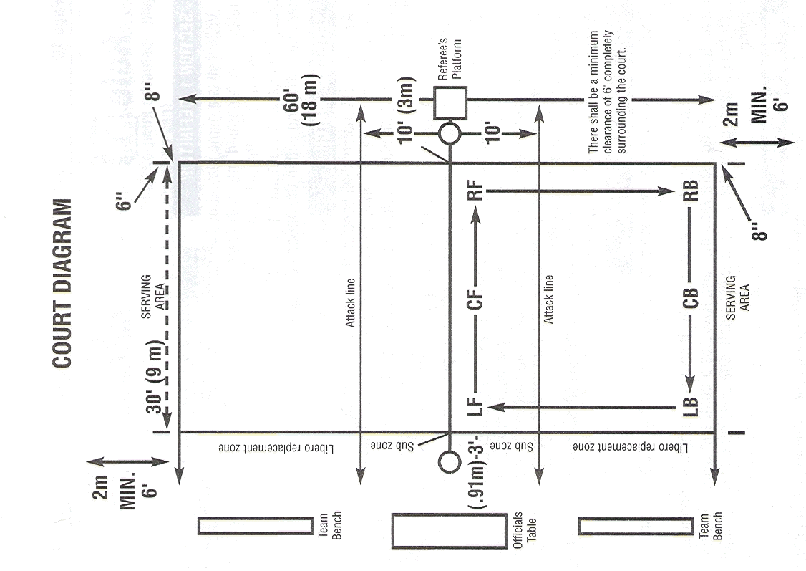

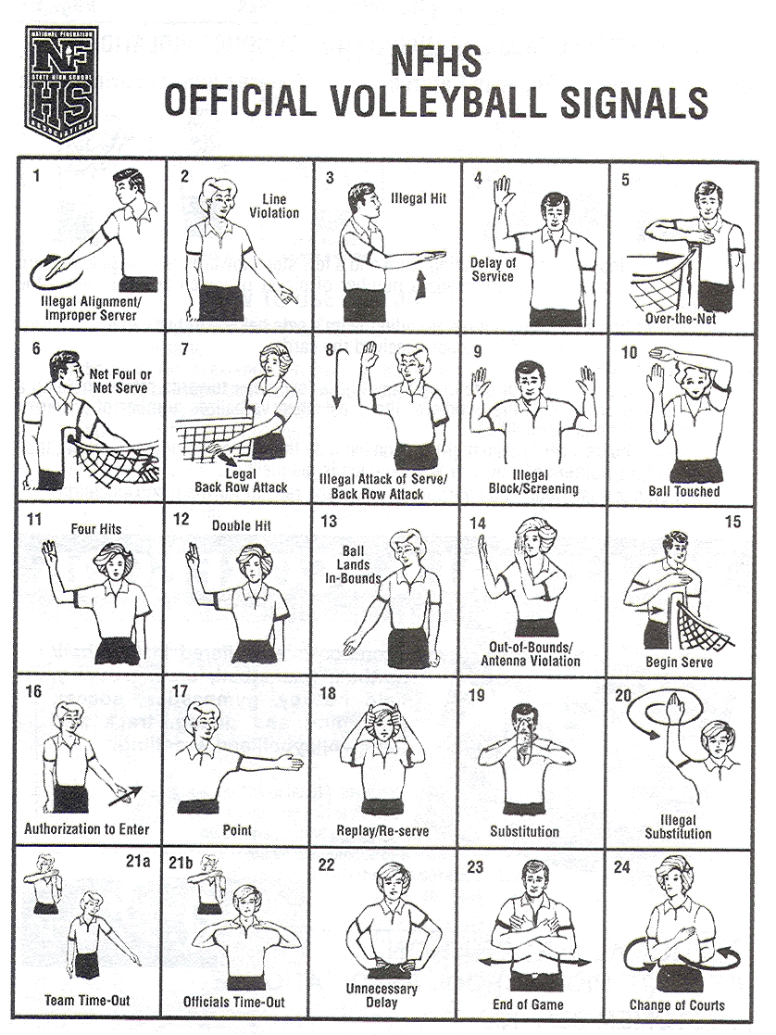
II. The Game
Volleyball is a game played by 2 teams of 6 players each on a rectangular court separated into 2 areas by a net. One team serves the ball over the net, trying to make it land within the opponent's playing area. The receiving team tries to return the ball back over the net and make it land within the opponent's playing area. Each team is allowed 3 offensive contacts with the ball before it must pass over the net. One player may hit the ball twice as long as the hits are not consecutive. If a team hits the ball four times, play is stopped (signal #11). In 2004 Federation Rules established rally scoring, where a point is scored by the team winning the rally regardless of who served. A point is awarded (signal #17) the serving team when the opponent violates a rule, the ball is hit out of bounds or the ball lands in their playing area. If the serving team violates a rule or the ball lands in their playing area a point is earned by the receiving team and the ball is awarded to that team as well. Play starts with the official blowing the whistle and does not end until a whistle is sounded. The game is won by the team who reaches 25 points first with at least a 2 point advantage over the opponent. The match will consist of the best two-out-of-three games to 25. If a third game is required to break a tie, that game is played to 25 points as well. (Optional, 3 out of 5 matches possible)
III Basic Rules
A. Serving
The server must wait for the referee to blow the whistle and signal (signal #15) before serving and has 5 seconds to serve or delay of serve will be called (signal #4). The server must stand between the service lines (anywhere behind the back line) and may not step into the court or line violation is called (signal #2). The ball must cross the net between the two antennas to be good. The ball is allowed to touch the net on the way over. If the server tosses the ball in the air and allows the ball to fall to the ground or catches the ball, the referee will signal a re-serve (signal #18) and the server has one more chance to serve. If the ball touches the server and hits the ground a point and the ball are awarded to the other team.
B. Ball Handling
Of all the rules in volleyball, this area is probably the most misunderstood. In general the ball is allowed to touch any part of a player above the waist. How long can the ball rest when it makes contact? Regardless of the technique used to make contact with the ball, it is the length of time the ball is in contact with the player that determines an illegal hit. The referee on the stand is the official with the responsibility to call ball handling errors. Double contact with the ball is allowed on any first ball over the net (even with finger action) as long as it is one single attempt to hit the ball. (Many of the other volleyball rules allow a player to play the ball with less restrictions on style and technique, even allowing the ball to be kicked)
1. Passing is the technique of allowing the ball to bounce off the forearms as though they were a solid board. If the player does not rebound the ball off his or her forearms quickly and it remains in contact too long, the referee will call an illegal hit (signal #3).
2. Setting is the technique of letting the ball momentarily touch the fleshy part of the fingertips and reverse the direction so it is set back into the air for another player to hit. If the setter allows the ball to come to rest too long, an illegal hit (signal #3) will be called. The ball must be set in one smooth continuous motion and not make contact with the palms. If the ball does not hit both hands simultaneously, it is a double hit violation except for any first ball over the net ( signal #12).
3. Spiking is the technique of forcefully hitting the ball into the opponent’s court with one hand. Usually the ball makes contact with the heel of the hand and the finger tips almost simultaneously.
4. Dinking is the technique of softly directing the ball over the net with one hand. The ball must be touching the finger tips only and must be directed in one continuous motion. Any prolonged contact or change of direction will be called an illegal hit (signal #3).
5. Power Dinking is a technique identical to a dink with the exception that it is done more forcefully.
6. Double contact on any first ball over the net is legal, even with finger action. (A spinning ball or ugly looking hit is not necessarily illegal. Referees are instructed to only call a double hit when they see two distinct contacts made.
C. Blocking
Blocking is the technique of preventing the opponent’s ball from coming on your side of the net. It is legal for a blocker to reach over the net on a block and angle his or her arms so that when the ball hits his or her open hands the ball will be deflected back into the opponent’s court. Each team has a right to use all three of their hits before sending the ball over the net. A blocker may always block the third hit or any other ball that is directed towards his or her court. If the blocker interferes with the opponent’s right to play the ball, over the net is called (signal #5). Once a ball hits a blocker’s hands, the teams have 3 offensive contacts with the ball in order to get it over the net.
Example 1: If team A spikes the ball on their third hit and it touches a blocker on the way over the net, team B will be allowed to make three more contacts to get the ball over the net, since a block is not counted as one of the teams three hits.
Example 2: If team A spikes the ball on their third hit and the blocker prevents the ball from crossing the net, team A now has an additional 3 contacts to get the ball over the net.
D. Center Line Violation
There is a two inch line that separates one court from the other under the net. A player is allowed to step on or touch this line with his or her hand and even extend over the line. It becomes a center line foul (signal #2) when the player’s foot or hand is completely over the line or any other part of their body is touching the floor on the other side of the line. A player may step over the center line extension as long as no contact is made with the opponents playing area and no interference with the opponent occurs. (Some rules allow contact of the opponents side under the net as long a there is not interference.)
E. Net Violations
A net foul (signal # 6) is called if a player touches any part of the net, net cables, or the antennas. If the player’s hair hits the net or if the ball causes the net to hit the player it is not a foul.
F. Back Row Attack
A back row player may legally attack the ball from anywhere behind the 10 foot attack line. (signal #7) If the back row player is in front of the 10 foot attack line, the player may not send the ball over the net if the ball is completely above the net at the time of contact.
G. Substitutions
Each team is allowed to substitute players during any dead ball. Each team is allowed a total of 18 subs per game with no individual limit. A coach does not have to call for a substitution. If a player from the bench enters the substitution zone, this is considered a legal request for substitution. Once a player enters the game for another player, that player may only return to the game in that same position. A coach may substitute as many players as he/she would like during each substitution request.
H. Libero (Not used in West County League – Used in 9th grade)
The libero is a specialized defensive player that may enter the game for any back row player. The libero wears a contrasting jersey to teammates, may not attack a ball that is above the height of the net, block, or overhand set the ball to an attacker while in front of the 10’ line. Once designated as the libero a team may not have a different libero until the next game accept in the case of an injury to the libero. The libero and the person they are replacing must make their exchange during a dead ball between the 10’ line and the serving line (not thru the end line). This exchange is not considered a team substitution The Libero is an optional role and is used at the discretion of the coach. (New in 07-08, the libero is allowed to serve in one position. A coach does not have to take advantage of this option.)
IV Officials Duties
A. Referee
The referee is located on the stand and is the head official. The referee follows the flight of the ball and makes the calls based on how, where, and by whom the ball is contacted. The referee relies on the umpire and line judges to help by making calls in their areas of responsibility. The referee also has general supervision of other officials, makes the final decision when it is apparent another official made an error. The referee shall administer any yellow or red cards as needed for unsportsmanlike conduct.
B. Umpire
The umpire is the official located opposite the referee at the base of the net. The umpire is mainly responsible for player entry during substitution, alignment violations on the receiving team, net and foot violations. The umpire concentrates on the activity that occurs primarily between the two 10 foot attack lines and does not generally follow the flight of the ball.
C. Line Judges
Line judges are responsible for indicating whether the ball is in or out of the court (a ball touching the line is in); whether the ball crosses the net between the antennas; and if a player touches a ball before it goes out of bounds (signal #10).
D. Scorekeeper / Timer
The scorekeeper and timer are responsible for keeping the official score and time for the game.
V Responsibilities
A. Players
It is the players’ responsibility to do the best they can do and be proud of what they have worked for and accomplished. Volleyball is a team sport that allows each player to provide his or her uniqueness to the sport. The more competitive the level of play, the harder it is to remember that having fun is an important part of the game.
B. Coaches
It is the coach’s responsibility to provide a learning, supportive environment for her or his players and to provide the atmosphere where each player can develop his or her potential. Coaches can play a key roll in establishing the attitude of players and spectators by their actions.
C. Officials
It is the officials’ responsibility to continue to study the game so they keep up with the rule changes. Players, coaches and fans expect and deserve the officials to be knowledgeable, fair, impartial, consistent and attentive.
D. Spectators
It is the spectators’ responsibility to enjoy the game within the bounds of good sportsmanship. It is fun and exciting to watch any competitive sport and natural to cheer for your team to win. Good fans also recognize good play and hard work from either side. Remember that each person on the court or the bench is someone's son or daughter who wants and deserves our admiration and respect for what they are working so hard to do.
VI Sportsmanship
The National Federation of State High School Associations has published the following statement concerning SPORTSMANSHIP:
There are high school athletes who are performing here tonight. They are friendly rivals as members of opposing teams. They are not enemies. This, basically, is the theme of interscholastic athletics..... the idea of friendly competition. The visiting team tonight, and in every interscholastic game, is a guest of the home team. The are expected to be so regarded and so treated.
The officials are men or women who, by agreement between the competing teams, are assigned to administer the rules of the game. Their experience and their integrity qualify them for their part in this friendly interscholastic contest. This attitude of sportsmanship should be reflected by all spectators too, no matter what their personal feelings of loyalty may be to one or the other of the teams in tonight's contest.
This booklet was written by Ken O'Day. It can be reproduced and used by any high school for the purpose for which it was written. Please distribute to your students, parents, and fans for a better understanding of the game of volleyball.

