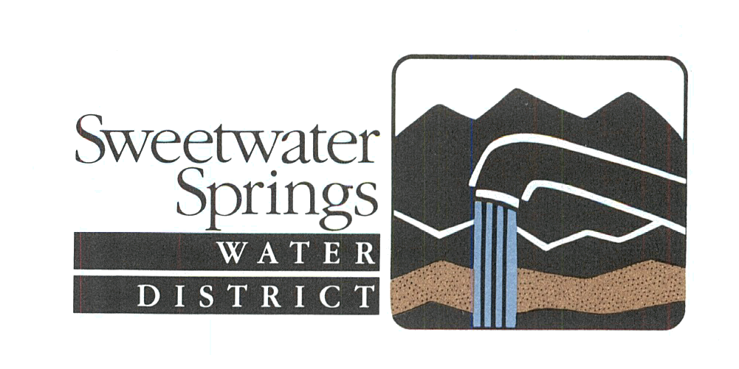

Sweetwater Springs
Water District

Annual Operating & Capital Improvement Budget

2014-15 Fiscal Year
(For the period July 1, 2014 - June 30, 2015)

Board of Directors

Richard Holmer, President
Tim Lipinski, Vice President

Sukey Robb-Wilder, Financial Coordinator
Victoria Wikle
Gaylord Schaap

General Manager

Steve Mack

Sweetwater Springs Water District
Annual Operating & Capital Improvement Budget
2014-15 Fiscal Year
Summary

In Fiscal Year 2014-2014 (FY15) Sweetwater Springs Water District has budgeted operating expenses of $1.6 million and capital improvement expenses of $3.2 million. Figures 1 and 2 respectively show the distribution of these expenses and sources of funds to pay for these expenses. Note that sources of funds are enhanced by approximately $600,000 from District Reserves for capital improvements. These figures do not include expenses or sources of funds for construction of the 2016 CIP for which the construction contract will be awarded in FY15 but the funds not expended until FY16 (approximately $800,000).
Table 1 is a summary of the FY15 Budget which is described and shown in detail in the following pages. The FY15 Budget is similar in form and content to prior years’ budgets. The FY15 Budget includes the fourth year of 3% increases for the Base Rate and Water Usage Charges and the second year of a 3% increase to the Capital Debt Reduction Charge which are designed to develop sustainable capital project funding.

2014-15 Fiscal Year (FY15) Budget

The annual budget of the Sweetwater Springs Water District (SSWD) allows the District to accomplish its mission which is to provide its customers with quality water and service in an open, accountable, and cost-effective manner and to manage District resources for the benefit of the community and environment. The District achieves its mission of producing good quality water by pumping Russian River underflow from five wells – 3 located at the Guerneville El Bonita well site and 2 located at the Monte Rio well site. That water is then treated in two separate treatment facilities at the Highlands site for Guerneville and at the Monte Rio well site and distributed through approximately 68 miles of distribution pipes and 3500 service laterals of varying lengths, and stored in 26 tanks and reservoirs. This system is managed and its operation administered by the District staff of 10 full time employees. The District has an aggressive capital improvement program aimed at maintaining and improving the capital infrastructure to industry standards to deliver high quality water, reduce system water losses, and maintain adequate system pressure and fireflow. The annual budget identifies the revenues and expenses that accomplish these tasks.

The FY15 Budget follows the format established in prior years and includes the fourth year of a 3% increase to the Base Rate and Water Usage Charges, and the second year of a 3% increase to the Capital Debt Reduction Charge.

3% increase to the Base Rate, Water Usage Charges, and Capital Debt Reduction Charge: Most of the revenues for the FY15 Budget come from water rates paid in bimonthly bills by District customers (Figure 2). In 2011 District staff did a comprehensive multi-year analysis to show that with small annual increases in rates the District can develop sustainable funding for needed capital projects to maintain District facilities once the current catch up capital improvement program is completed. The financial analysis showed that annual 3% increases over nine years will build into $500,000 available annually for capital projects. This is the fourth year of planned annual 3% rate increases designed to achieve the sustainable capital improvement program. More information on the District’s water rates and a water rate calculator can be found on the District’s website at www.sweetwatersprings.com.

FY 2015 CIP and FY 2016 CIP (Table 2): The FY15 Capital Budget includes the 2015 Capital Improvement Program (CIP), which is replacement of 5,800 ft of existing main and appurtenances on Old Monte Rio Road commencing at the Handy Andy Booster and proceeding westerly to the Highway 116 intersection, estimated to have a total cost of approximately $1,215,000 including design, inspection, construction management and construction costs. Approximately $1.1 million of the total costs will occur in FY15.

The FY15 Budget also includes the obligation for funding construction of the FY 2016 CIP, which is replacement of approximately 3,900 ft of existing mainline and 75 services along Canyon 1 Road, Memory Lane, and Memory Park Road in Rio Nido. This expense is included in the FY15 Budget because design costs will start in autumn 2014 and the construction contract would be obligated in May or June of the fiscal year. However, most of the expense will occur in FY16. These are projects indentified in the District’s FY14-19 CIP and are needed improvements to the District’s distribution system.

District Reserve Policy: A formal District Reserve Policy was approved in September 2009. The Reserve Policy allows the District to gauge its financial health and adequately plan for its future, and allows ratepayers to follow this planning. The District Reserve Policy has the following components:

- Operating Budget Cash Reserve - 15% of the annual Operating Budget expenses to provide for prompt payment of operating expenses at the start of the fiscal year.
- Operating Reserve – 25% of the Operating Budget for unanticipated expenses for economic downturn or other economic crisis, or for dealing with emergencies and disaster-related expenses.
- Debt Repayment Reserve - 25% of all payments for principal and interest on all District loans to ensure funding is available to repay existing District debt.
- Capital Reserve – 25% of the nominal Capital Budget of $1 million for similar issues with the capital program.

The sum of all district funds is shown in the budget as Total Reserves End of Year (EOY). This is the sum of the District discretionary funds, listed in the budget at the end of the year. The difference between Total Reserves EOY and Total District Policy Reserves is Reserves Above District Policy. The District goal is to keep this number positive. The amount above the District Policy Reserve is the amount the District has for future capital projects. The Reserves Above District Policy is a good measure of where we are in funding an ongoing capital program. The Draft FY15 Budget projects that the District will have approximately $1.7 million in Reserves Above District Policy at the end of FY15, including the obligation for the FY16 CIP. This means cash on hand in the Reserves Above District Policy will be approximately $2.5 Million at the end of FY15.

Other Financial Assumptions/Highlights of the FY15 Budget include:

- Water Sales will be flat in FY15 – our assumption is that a 3% rate increase will result in a 3% revenue increase in water sales.
- Salaries are increased to match the approved Memorandum of Understanding and contracts for nonrepresented employees and includes the savings of the General Manager in partial retirement.
- The transfer to the Capital Improvement Revenue Fund (CIRF) is budgeted at $500,000 in FY15.

Line Item Highlights of the FY15 Budget:

The FY15 Operating Budget provides for ongoing costs consistent with previous years’ expenditures, except where identified below.

The operating budget encompasses the “expenditures related to the operation, maintenance and repair of water facilities”, as well as the billing, collections, accounting, fiscal management and other overall administration.

Water Bill Revenue line items have been adjusted to reflect the 3% increases on projected sales revenue in the Base Rate and Water Usage Charges based on flat water sales. Capital Debt Reduction Charge (CDRC) revenue also includes a 3% increase. Operating interest is continued at a relatively low amount to reflect continuing lower interest on deposited funds.

Under Expenses, Salaries are budgeted to have almost no change which reflects a full year of the General Manager’s partial retirement and the District salary savings from that. Benefits are budgeted to decrease approximately $13,000 because of a reduction in the amount paid for retiree health and a reduction in workers comp insurance costs. Salaries and Benefits are a major District expense – approximately 70% of the FY15 Operating Budget expenses.

Total Supplies and Services are approximately $20,000 lower than the FY14 approved budget. Maintenance/Repair – Facilities is a big cost item in Supplies and Services and has been decreased to reflect the projected costs in FY14 which will likely be similar for FY15. Governmental Fees are budgeted to remain flat in the coming fiscal year. Professional Services has decreased based on actual costs for legal services in FY14. Electricity is a big expense item and is expected to have an increase in FY15 ($10,000) but there is some uncertainty to this number because the District may be moving to a new provider (Sonoma Clean Power).

Fixed Asset Expenditures has been substantially increased to budget for the purchase of a new truck. There are also substantial expenses for Tank/Facilities Sites to replace the chlorination system for the Monte Rio System and a tank liner at the Park Avenue Tank.

The Operating Budget has a surplus of approximately $794,000 which is transferred as revenue to the Capital Improvement Budget as Capital Improvement Revenue Fund (CIRF) ($500,000) Building Fund ($15,000), In-House Construction Fund ($25,000), and CDRC revenue ($253,947).

The FY15 Capital Budget major expenses are the FY 2015 CIP (estimated cost $1,000,000) and FY 2016 CIP (estimated cost $900,000), described above and in Table 2.

Capital Interest revenue is estimated conservatively to reflect expected continuing low interest rates this coming year.

Capital Debt is a major expense item – approximately $1.0 million and 27% of total District annual expenses. District Capital Debt includes:

- General Obligation (GO) Bonds – $1.6 million in bonds that were approved to purchase the District and make needed capital improvements and refinanced last year. Paid off in 2042. Annual payment - $72,000.
- Cap One Bond – The District refinanced the first 20 years of the GO Bonds in September 2013. Paid off in 2033, the FY15 payment is $566,508, saving the District approximately $45,000 in the FY15 fiscal year.
- State Loans - two loans for approximately $3 million which were approved in 1995-96 for needed improvements. Paid off in 2021-22. Annual payment - $170,168.50.
- Private Placement Loan. $3 million loan acquired in 2008 for needed capital improvements. Paid off in 2028. Annual payment - $234,012.

District Reserves and Funds and Loan Balances show the District’s continuing healthy financial picture.

As discussed above reserve balances are a good measure of the health of the District’s finances. For FY15, District Policy Reserves are at $1,150,528 and Reserves Above District Policy at the end of the year are $1,737,530. This includes the obligation for the FY 2015 CIP, so actual cash on hand reserves at the end of FY15 will be approximately $2.5 million.

The detailed FY15 Budget is included as Attachment A.

Table 2. Sweetwater Springs Water District 2014-2015 Capital Improvement Program (CIP)
Year | Projects | Estimated Cost
2015
 | Old Monte Rio Road (GV) – Replace 5,800 lf of existing main and appurtenances commencing at the Handy Andy Booster and proceeding westerly, 50 services. | $1,240,000
2016
 | Canyon 1 (Rio Nido) Replace approximately 3,900 ft of existing mainline and 75 services along Canyon 1 Rd., Memory Ln., Memory Park Rd. | $975,000
 | 2015-2016 Totals | 2,215,000

